TECHNICAL DOCUMENTATION
FinTrack Prime
Frontend (Client-Side) Application

Project | FinTrack Prime
Component documented | Client-side (frontend) application
Prepared by | [Student name(s)]
Date | [Defense/submission date]

1. Introduction
This document describes the technical implementation of the FinTrack Prime frontend: the technologies it is built with, how users are authenticated, how the interface is styled, and how each screen gets its data. It is scoped to the client-side (browser) application only. The backend (an ASP.NET Core Web API) is a separate project; it is referenced here only where the frontend directly depends on it — the API endpoints it calls and the data shapes it expects.
Everything in this document is drawn directly from the project's source code and configuration files, not from assumptions about how a typical app of this kind might be built.

2. Technology Stack
Core technologies used to build and run the application, with the exact versions pinned in package.json:
Layer | Technology | Version | Purpose in this project
Language | TypeScript | ~6.0.2 | Static typing across the whole codebase
UI library | React | ^19.2.8 | Component-based UI rendering
Build tool | Vite | ^8.2.0 | Dev server and production bundling
Routing | React Router | ^7.11.0 | Client-side page navigation and route guards
Server-state | TanStack Query | ^5.101.4 | Fetching/caching data from the backend API
HTTP client | Axios | ^1.19.0 | All REST calls, with a JWT-attaching interceptor
Styling | Tailwind CSS | ^4.3.3 (v4) | Utility-first styling driven by design tokens
Component primitives | Radix UI | 1.x (10 packages) | Accessible unstyled building blocks (dialog, dropdown, tabs, etc.)
Icons | lucide-react | ^1.28.0 | Consistent icon set across the app
Charts | Recharts | ^3.10.1 | All reporting/dashboard charts
PWA | vite-plugin-pwa | ^1.3.0 | Installable app, offline fallback, service worker
Linting | oxlint | ^1.75.0 | Static code checks (npm run lint)

2.1 Radix UI packages used
- @radix-ui/react-accordion, react-avatar, react-dialog, react-dropdown-menu,
- react-progress, react-select, react-slider, react-switch, react-tabs,
- react-toast, react-tooltip
Note: Radix supplies unstyled, accessible behaviour (focus trapping, keyboard navigation, ARIA attributes); all visual styling is applied with Tailwind on top of it.

3. Project Structure
The application source lives under src/, organized by responsibility rather than by page:
Folder | Contains
src/pages | One file per screen (Login, Dashboard, Budget Planner, Cash Flow, Upgrade, the 4 premium tools, etc.)
src/components | Shared, non-page components (AppLayout, Sidebar, TopNav, modals, route guards)
src/components/ui | The 24-component design-system library (Button, Input, Card, Modal, Table, Toast, etc.)
src/context | React Context providers: AuthContext (session), ThemeContext (light/dark)
src/api | One file per backend domain (auth, accounts, budgetPlanner, cashFlow, checkout, loanCalculator, investmentTracker, retirementPlanner, financialStatement) plus the shared Axios client
src/hooks | Reusable hooks: useDebouncedCallback, useGoogleIdentityScript, useInstallPrompt, usePayPalScript
src/types | Shared TypeScript interfaces mirroring the backend's view models
src/config | Navigation configuration (single source of truth for sidebar/breadcrumbs)
src/utils | Small helpers: class-name merging, number formatting, API error parsing

3.1 Layered architecture
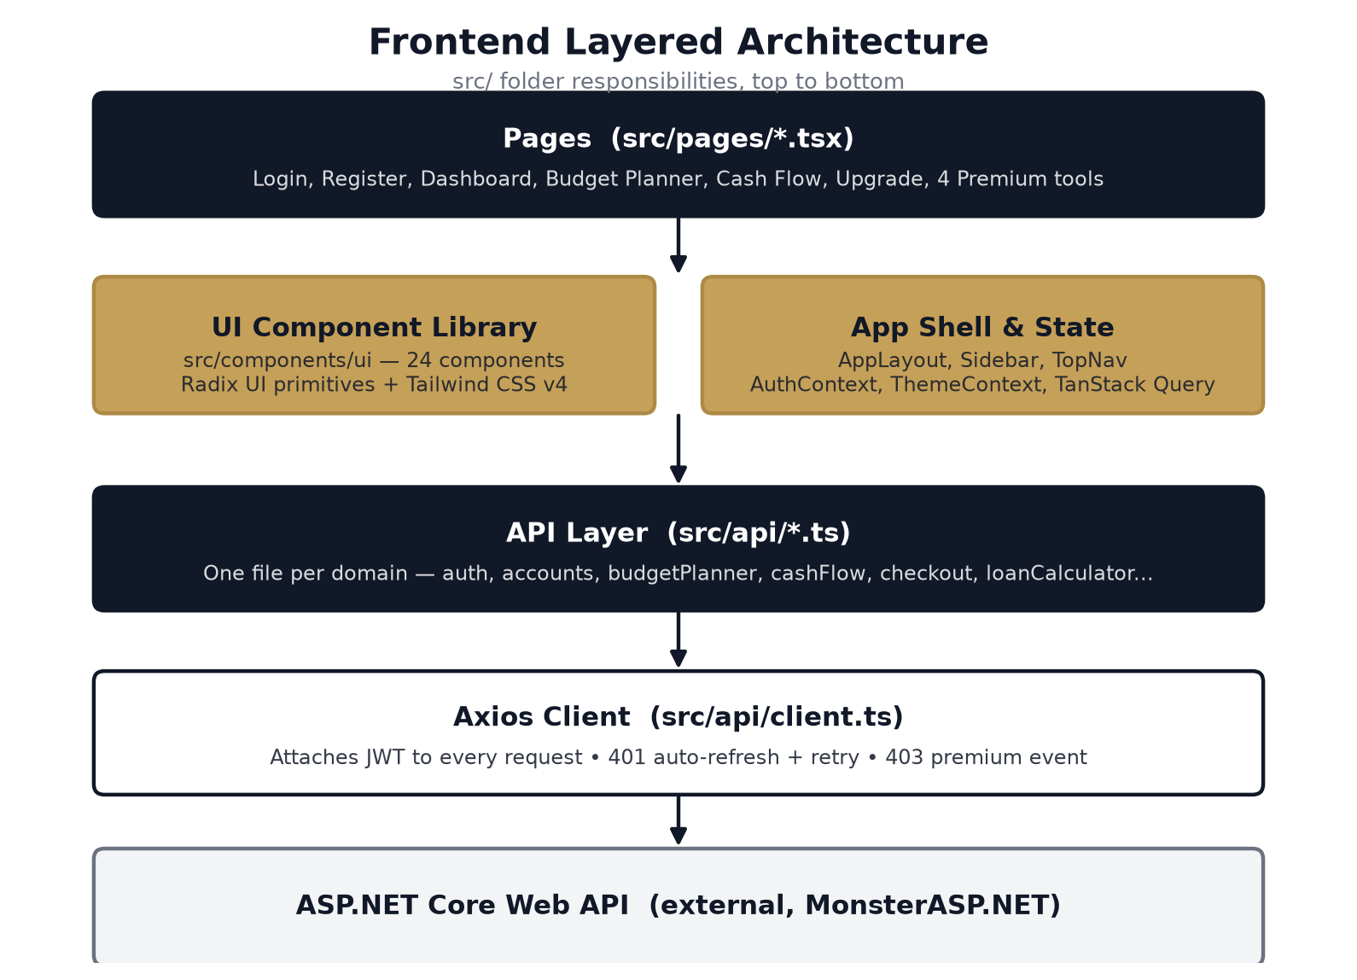
Figure 1 — How a page's request reaches the backend, layer by layer.

4. Authentication Mechanisms
The application supports two ways to sign in, both of which end in the same kind of session: a short-lived JSON Web Token (JWT) kept in memory, backed by an HttpOnly refresh cookie the browser cannot read directly.

4.1 Email and password
The Login and Register pages collect credentials and call POST /api/auth/login or POST /api/auth/register (src/api/auth.ts). A successful response is an AuthResponse: an access token, its expiry timestamp, the user's name/email, and the list of premium tools already unlocked.

4.2 Google Sign-In
GoogleSignInButton (src/components/GoogleSignInButton.tsx) loads Google's Identity Services script directly — there is no npm package for this, just a <script> tag loaded by the useGoogleIdentityScript hook. Once loaded, it renders Google's own button and receives a signed ID token when the user picks an account. That token is sent to POST /api/auth/google, which returns the same AuthResponse shape as password login/register — so the rest of the app (AuthContext, route guards) treats every sign-in method identically.
Note: The Google Client ID is supplied through the VITE_GOOGLE_CLIENT_ID environment variable and must exactly match the ID configured on the backend, or the backend rejects the token.

4.3 Session handling and automatic refresh
- The access token is kept only in memory (src/api/authSession.ts) — a page refresh starts with none.
- On every app load, the frontend silently calls POST /api/auth/refresh, trading the HttpOnly ftp_refresh cookie for a new access token before deciding whether the user is logged in.
- AuthContext schedules a proactive refresh shortly before the current token's expiry, so an in-flight request never straddles the boundary.
- The Axios response interceptor (src/api/client.ts) catches any 401 from a non-auth endpoint, refreshes once, and retries the original request. Concurrent 401s share one in-flight refresh call rather than each racing their own.
- If refresh itself fails, the session is cleared and an AUTH_EXPIRED_EVENT is dispatched, which logs the user out and redirects to /login from anywhere in the app — not a per-screen check.

4.4 Route protection
Component | Behaviour
ProtectedRoute | Wraps every authenticated route; redirects to /login if there is no session (waits for the startup refresh to settle first).
PremiumRoute | Wraps each of the 4 premium-tool routes; redirects to /upgrade?tool=<name> unless that specific tool is in the user's unlockedTools list.

Note: PremiumRoute is a frontend convenience only, so a non-premium user isn't shown a screen that would immediately fail. The real access control is enforced by the backend's per-tool authorization policy.
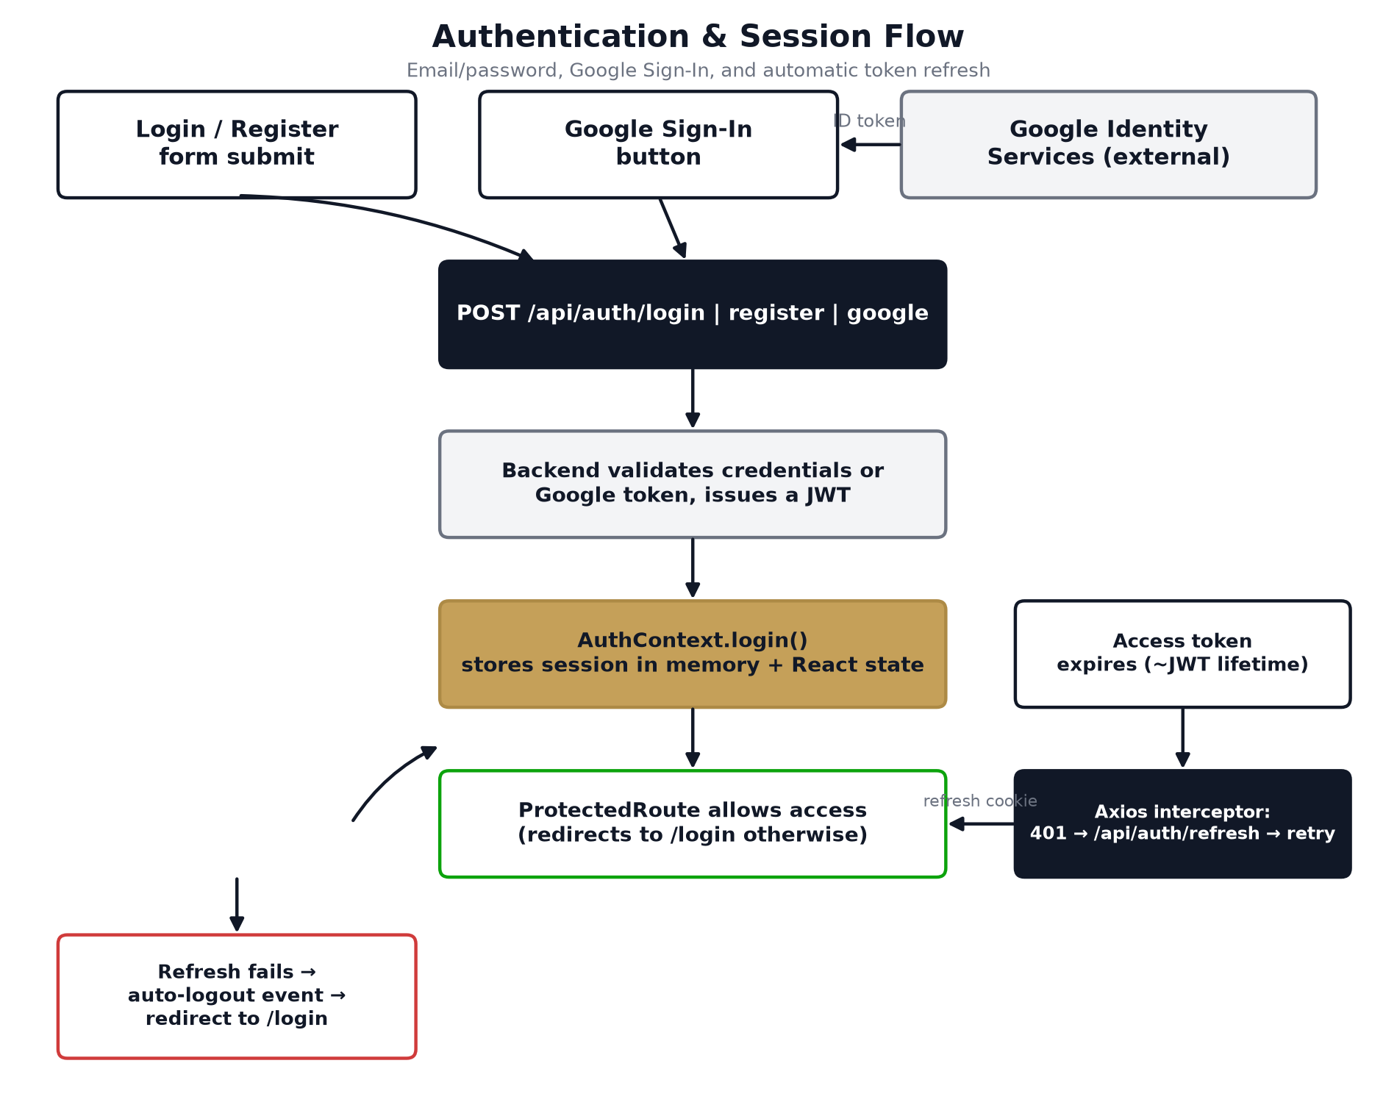
Figure 2 — Sign-in (password or Google) and the automatic refresh/retry cycle.

5. Styling System
Tailwind CSS v4 provides all styling, configured through CSS custom properties (design tokens) in src/index.css rather than a JavaScript config file — Tailwind v4's @theme block.

5.1 Design tokens
Token group | Examples | Purpose
Brand colors | --color-ft-navy, --color-ft-gold, --color-ft-blue | The fixed brand palette, carried over from the original site
Semantic surface/text | --color-surface, --color-text-primary, --color-border | Components read these, never raw hex — so theme changes never touch component code
Status colors | --color-status-good/warning/serious/critical | Reserved for state (e.g. an unusual-transaction flag), never reused for chart series
Chart colors | --color-chart-series-1 … 8, sequential, diverging | A colorblind-safe reference palette dedicated to charts
Typography | --font-display (Libre Caslon Text), --font-body (Public Sans) | Serif display type paired with a sans body face, matching the original brand

5.2 Light and dark mode
Dark mode is class-based: a .dark class on <html> re-maps the semantic tokens above via Tailwind v4's @custom-variant. ThemeContext reads the saved preference from localStorage (falling back to the OS-level prefers-color-scheme), and a ThemeToggle component flips it.

5.3 Component library
24 shared components live under src/components/ui, each independently responsive rather than relying on a parent's breakpoint:
- Inputs: Button, IconButton, Input, Select, Textarea, Checkbox, Switch, Slider
- Layout/display: Card, Badge, Avatar, StatCard, Table, Breadcrumbs, EmptyState
- Navigation/overlay: Tabs, Accordion, Modal, DropdownMenu, Tooltip, Toast
- Feedback: Skeleton, Spinner, ProgressBar
- Theme: ThemeToggle
Note: Several of these (Select, Switch, Slider, Tabs, Accordion, Dialog, DropdownMenu, Tooltip, Toast, Avatar, Progress) are Tailwind-skinned wrappers around the matching Radix UI primitive.

6. State & Data Management
Tool | Used for
TanStack Query | Server data that benefits from caching/refetching: dashboard, budget planner, cash flow, and every premium tool's data.
React Context | Small, truly global state that doesn't need Query's caching: the current session (AuthContext) and the light/dark theme (ThemeContext).
Local component state | Per-screen editable state (e.g. budget category amounts) so the UI updates instantly, before any network round trip completes.

6.1 Axios client behaviour (src/api/client.ts)
- withCredentials: true so the HttpOnly refresh cookie round-trips with every request.
- A request interceptor attaches Authorization: Bearer <token> whenever a token exists.
- A response interceptor reacts to 401 (refresh + retry, see Section 4.3) and 403 (dispatches a PREMIUM_REQUIRED_EVENT) globally, instead of every screen checking status codes itself.

7. Reporting & Data Visualization
All charts across the app are built with Recharts. Each reporting screen pulls its numbers from one backend endpoint and renders them without any client-side recalculation of totals beyond what's needed for instant-feel editing (Section 9):
Screen | Route | Chart(s) | Data source
Cash Flow Dashboard | /cash-flow | Expense-by-category bar chart, monthly income-vs-expenses trend line | GET /api/cash-flow
Budget Planner | /budget-planner | Expense-breakdown chart, recomputed live from local edits | GET/PUT budget category endpoints
Loan Calculator | /loan-calculator | Remaining-balance-over-time chart | POST /api/loan-calculator/calculate
Investment Portfolio Tracker | /investment-tracker | Allocation pie chart | Investment holdings endpoints
Retirement Planner | /retirement-planner | Projected-balance-by-age area chart | PUT /api/retirement-planner
Financial Statement | /financial-statement | Assets-vs-liabilities bar chart | Financial statement endpoints

Note: Recharts alone pushes the production bundle over Vite's default 500 kB chunk-size warning threshold. This is a known, accepted trade-off for this project's scope, not a build error; code-splitting it is a reasonable later optimization.

8. Payments Integration
The Upgrade screen (/upgrade) renders PayPal's Buttons SDK, loaded via the usePayPalScript hook using the VITE_PAYPAL_CLIENT_ID environment variable. On approval, the frontend calls actions.order.capture() client-side (required before the order's status becomes COMPLETED), then sends the resulting order id to POST /api/checkout/verify. On success, the backend's response is a fresh JWT with the newly purchased tool included in unlockedTools, and the app logs the session in with it immediately — the old token is discarded rather than left to expire naturally.
Note: The displayed/charged price ($49.00 USD) is hardcoded in UpgradePage.tsx and must match the backend's configured price; changing one side without the other is a known footgun called out directly in the project's README.

9. Interaction Pattern: Debounced Auto-Save
The Budget Planner, Investment Tracker, and Retirement Planner all edit data inline (category amounts, holdings, sliders) using the same pattern, via the useDebouncedCallback hook: local state updates on every keystroke so totals and charts feel instant, while the actual network write is debounced 400-500ms after the user stops interacting. The backend is never hit on every keystroke, and the screen never waits on the network to feel responsive.

10. Progressive Web App (PWA) & Build Tooling
Concern | Implementation
Installability | vite-plugin-pwa generates a Web App Manifest (name, icons, standalone display, navy theme color).
Offline app shell | Workbox precaches built JS/CSS/HTML/fonts so the app loads and navigates offline.
Offline fallback | public/offline.html — a static page (not a React route) served when a navigation misses the precache.
API data caching | Explicitly set to NetworkOnly for /api/* — a stale balance shown as if live is treated as worse than showing nothing.
Icons | Generated from an on-brand SVG by scripts/generate-pwa-icons.mjs (using the sharp package) into the 192/512/512-maskable/apple-touch sizes.
Install prompt | useInstallPrompt hook surfaces the native beforeinstallprompt event as an in-app "Install app" button.

10.1 Build & quality checks
Command | What it does
npm run dev | Vite development server
npm run build | TypeScript project build (tsc -b) followed by the Vite production build
npm run lint | oxlint static analysis
npm run preview | Serves the production build locally

11. Environment Configuration
Configured per-environment via a .env.local file (Vite convention: only variables prefixed VITE_ are exposed to the browser):
Variable | Purpose
VITE_API_BASE_URL | Base URL of the backend API (e.g. https://localhost:5001 in development; the deployed MonsterASP.NET URL in production).
VITE_PAYPAL_CLIENT_ID | PayPal Sandbox/Live app's public client id, used by the Buttons SDK.
VITE_GOOGLE_CLIENT_ID | Google OAuth Web Client ID; must match the backend's configured Google client id exactly.

12. Route Map
Route | Screen | Access level
/login | Login | Public
/register | Register | Public
/dashboard | Account Dashboard | Authenticated
/budget-planner | Budget Planner | Authenticated
/cash-flow | Cash Flow Dashboard | Authenticated
/upgrade | Upgrade / paywall | Authenticated
/loan-calculator | Loan Calculator | Authenticated + Premium (LoanCalculator)
/investment-tracker | Investment Portfolio Tracker | Authenticated + Premium (InvestmentTracker)
/retirement-planner | Retirement Planner | Authenticated + Premium (RetirementPlanner)
/financial-statement | Financial Statement | Authenticated + Premium (FinancialStatement)

Appendix A — Full Dependency List
Package | Version | Type
react | ^19.2.8 | dependency
react-dom | ^19.2.8 | dependency
react-router-dom | ^7.11.0 | dependency
@tanstack/react-query | ^5.101.4 | dependency
axios | ^1.19.0 | dependency
recharts | ^3.10.1 | dependency
lucide-react | ^1.28.0 | dependency
vite-plugin-pwa | ^1.3.0 | dependency
@radix-ui/react-accordion | ^1.2.20 | dependency
@radix-ui/react-avatar | ^1.2.6 | dependency
@radix-ui/react-dialog | ^1.1.23 | dependency
@radix-ui/react-dropdown-menu | ^2.1.24 | dependency
@radix-ui/react-progress | ^1.1.16 | dependency
@radix-ui/react-select | ^2.3.7 | dependency
@radix-ui/react-slider | ^1.4.7 | dependency
@radix-ui/react-switch | ^1.3.7 | dependency
@radix-ui/react-tabs | ^1.1.21 | dependency
@radix-ui/react-toast | ^1.2.23 | dependency
@radix-ui/react-tooltip | ^1.2.16 | dependency
typescript | ~6.0.2 | devDependency
vite | ^8.2.0 | devDependency
@vitejs/plugin-react | ^6.0.4 | devDependency
tailwindcss | ^4.3.3 | devDependency
@tailwindcss/vite | ^4.3.3 | devDependency
oxlint | ^1.75.0 | devDependency
sharp | ^0.35.3 | devDependency
@types/react | ^19.2.17 | devDependency
@types/react-dom | ^19.2.3 | devDependency
@types/node | ^24.13.3 | devDependency

